Arnoldas Kurbanovas

INF 202 Stage 2

**Summary:** Making a video game database to organize all the video games collected during my years of being a gamer. So many video games for different systems with different genres that its hard to keep track of them all especially of ones you recently played and where you last left off.

**Goal/mission:** Main goals are to be able to sort video games by name, genre, and video game console for which each game is made for. Sub-goals are to show date of last played for each video game and the current progress in that particular video game.

**General objectives:** This will be a relational database used by me to help be able to retrieve my video games by the specified requirements.

**Steps:**

1.determine the input and output requirements (both immediate and potential) Can be expressed as use cases!

2.develop data model to support those requirements. (in specific detail)

**Class objectives:**

a) Each use case is a separate object.

b) Entering information about requirements is a task that a user might want to perform independently of any video games. At some later time, the same user, or someone else, may want to enter details of a video game and relate it to the requirements that are already in existence.

c) Info about each object is recorded as a row in a table.

d) the video game is the class! (might change)

e) Each individual video game is referred to as an object in the video game class!

f) Information about each video game is the attributes!

**Use Case Diagram:**

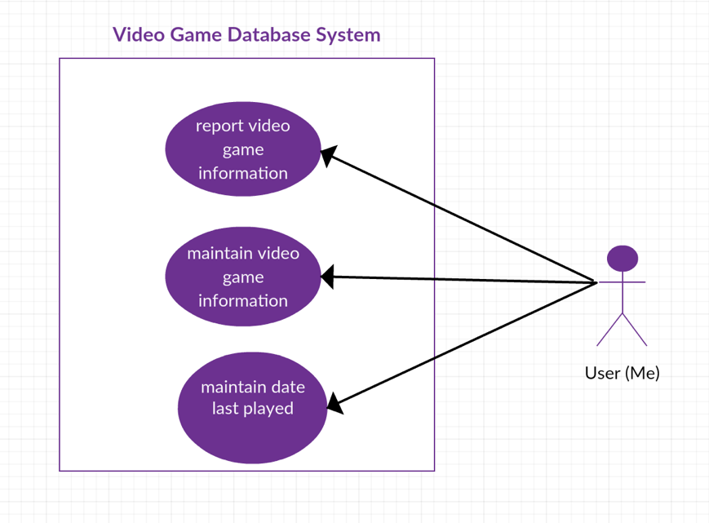

**use cases:**

use case: report video game information: for each date last played object, write out the name of the video game and find out all the associated genre objects. for each genre objects, write out the genre name and all the associated ratings and ...

use case: maintain video game information - create a video game object. enter unique id number and associate new video game object with any other objects that exist.

use case: maintain date last played - enter or update the date last played object. Enter date.

use case 1.maintain video game information - enter or edit all the information we have for each video game, that includes: name, genre, date last played, progress, rating, and summery.

b.report information about video games - find or report information about a video game or all video games and see which one the user wants to choose.

c.report information based on NEEDS… specify a need and find appropriate video game (or report for all information)

possible NEEDS by user: requirements of the user:

a.user wants to find video game based on genre.

b.user wants to see video games in order of based on date last played.

c.user wants to search video game by name to see video game progress.

d. user wants to search video game by name to see video game rating and summery.

**Data Model:**

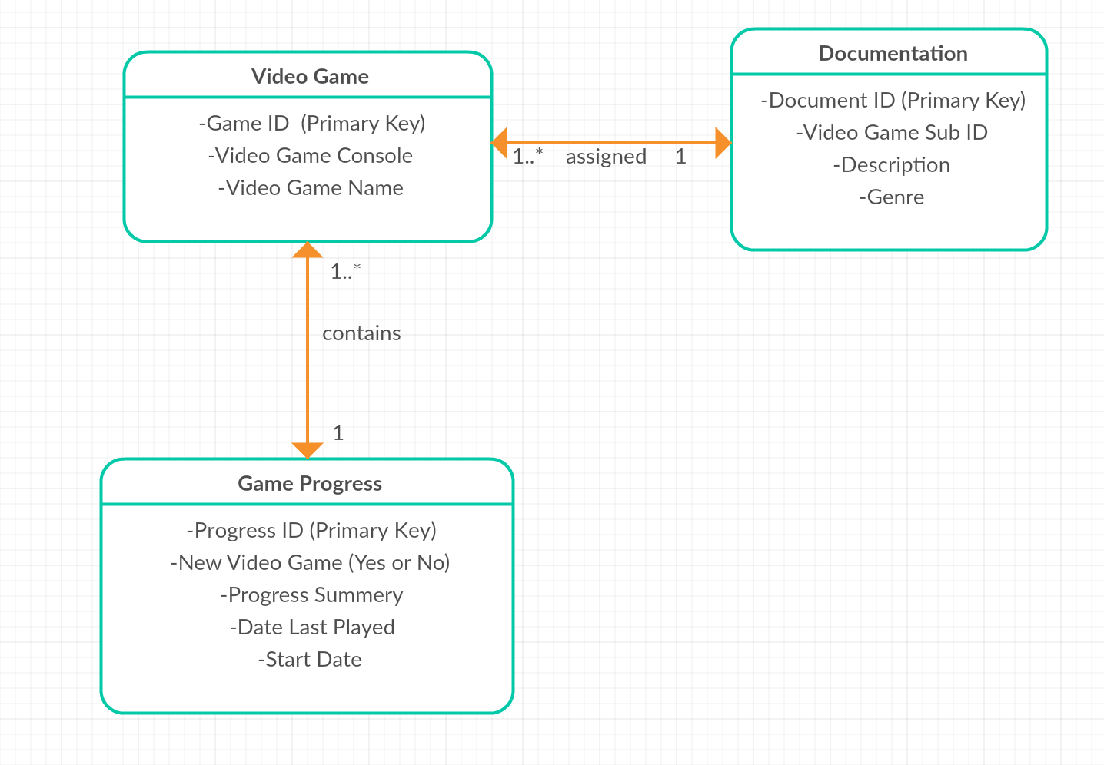

**Output goals:**

1. Relational database having the first table with each video game name corresponding with a number.
2. another table with the corresponding numbers and date of last played, progress in video game. These will change with each use of video game.
3. another table with corresponding numbers showing the rating of the video game, the genre, system the video game is used for and description of video game. These will not be changing.